PLANETS DB

AIM: To implement a prolog program for PLANETS DB.

OBJECTIVES:
- To develop a Prolog program that stores information about planets in a database and allows the user to query details such as the planet's type, position, moons, and other properties.
ALGORITHM:
- Start the Prolog program.
- Define facts containing information about different planets.
- Define rules to retrieve planets based on their properties.
- Load the program into the Prolog interpreter.
- Ask queries such as planet(X), terrestrial(X), or has_moons(X).
- Display the matching results.
- Stop..

SYSTEM-ARCHITECTURE:
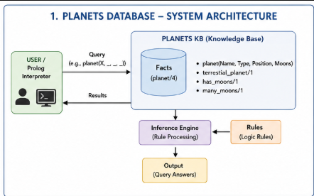

PROGRAM:
% PLANETS DATABASE

% planet(Name, Type, DistanceFromSun, Moons).

planet(mercury, terrestrial, 1, 0).
planet(venus, terrestrial, 2, 0).
planet(earth, terrestrial, 3, 1).
planet(mars, terrestrial, 4, 2).
planet(jupiter, gas_giant, 5, 95).
planet(saturn, gas_giant, 6, 146).
planet(uranus, ice_giant, 7, 28).
planet(neptune, ice_giant, 8, 16).

% Rule to find terrestrial planets
terrestrial_planet(X) :-
planet(X, terrestrial, _, _).

% Rule to find planets having moons
has_moons(X) :-
planet(X, _, _, M),
M > 0.

% Rule to find planets with more than 10 moons
many_moons(X) :-
planet(X, _, _, M),
M > 10.

OUTPUT:
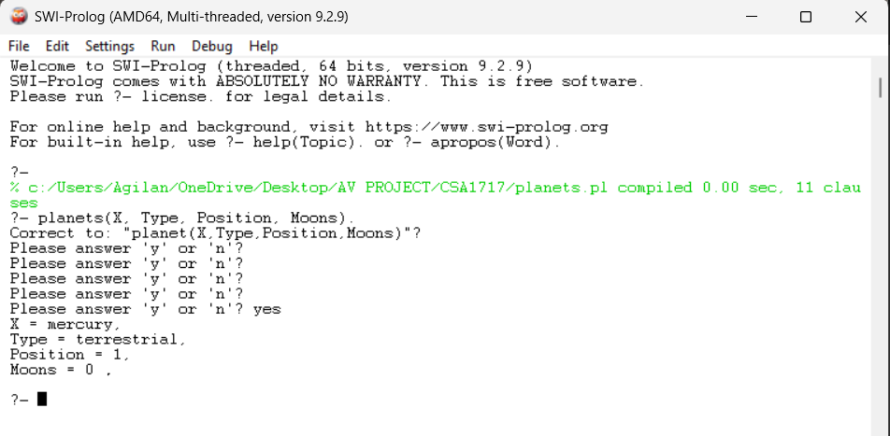

RESULT: Thus the PLANETS DB is implemented successfully using Prolog program.

